- Given a log file:
- Find all the errors in the log and dump them to a new file.
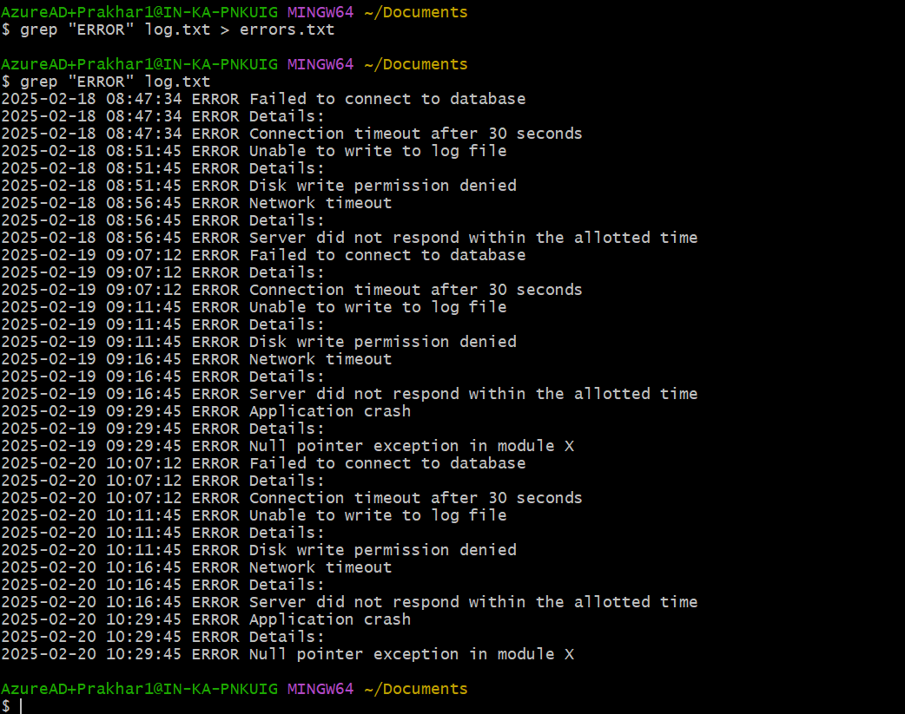

It also created a error.txt file in the desktop folder:
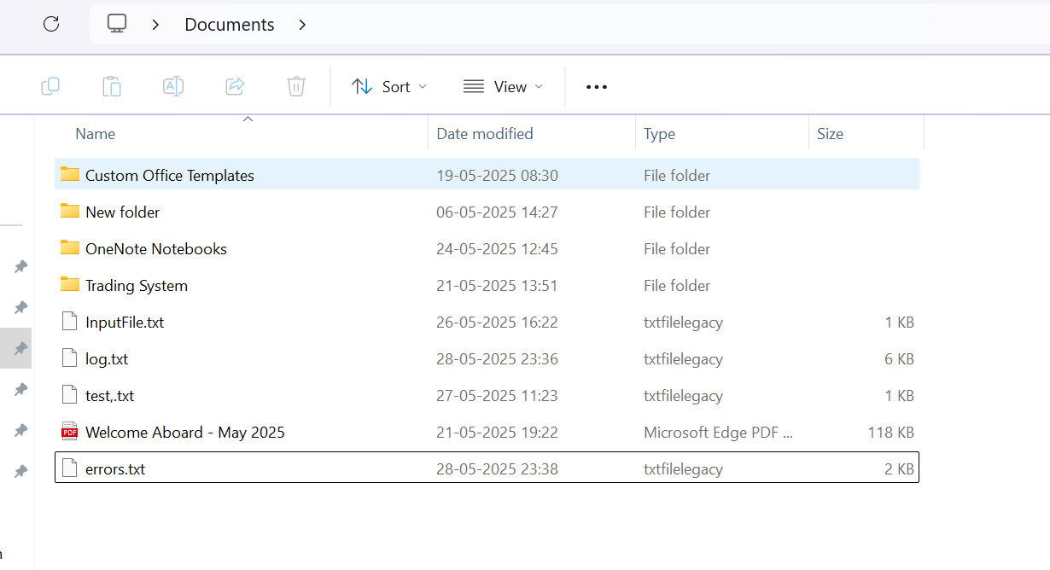

b. What events occurred between 09:10 and 09:19?
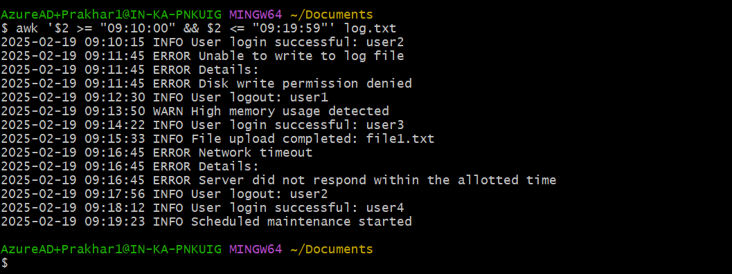

c. How many INFO messages are in the log file?


d. Print the first 5 lines of the file.
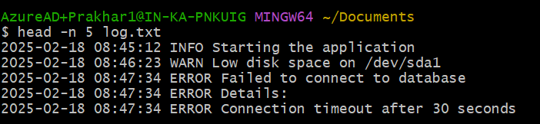

e. Print the last 5 lines of the file.
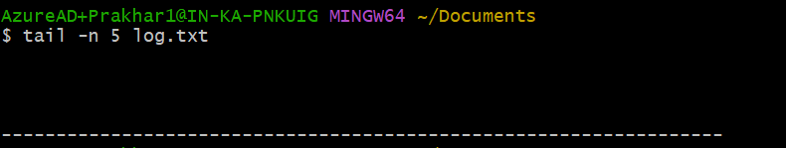

f. Print lines if the lines contain error, fail, or warning.
Use -i to enable case-insensitive search
-E: extended regular expressions
This allows you to use extended regex features like | (OR operator) without needing to escape them. In short - Use extended regular expressions for pattern matching.
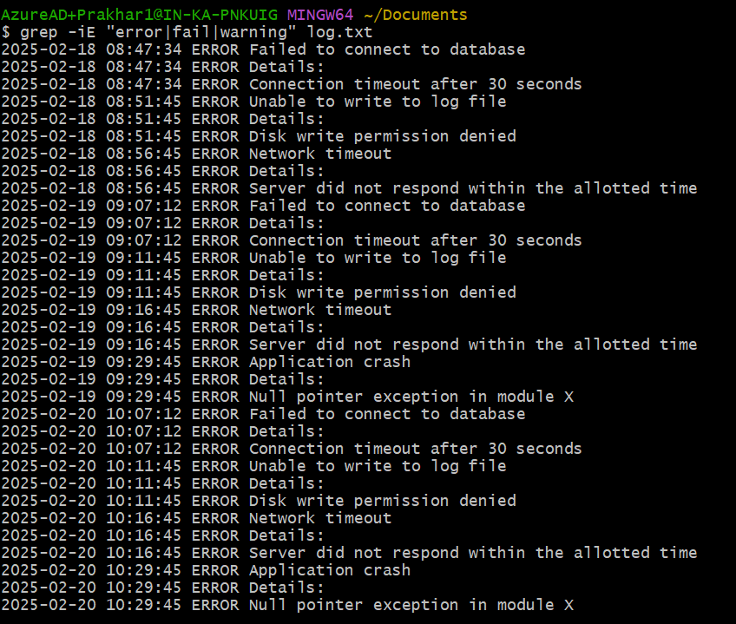

g. Rename the file to new_log.txt.

h. Edit the log file and add the string "hello, world!" at the beginning of the file.
Used vi new_log.txt to add text at top.
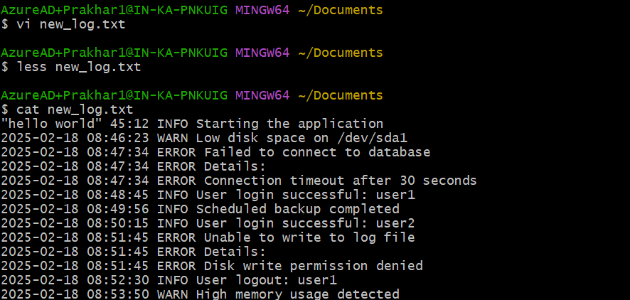
Can also use: sed -i '1i hello, world!' new_log.txt
Breakdown (for my understanding):
- sed — Stream editor, used to modify files line-by-line.
- -i — In-place editing:
  - This tells sed to modify the file directly, instead of printing the result to the terminal.
  - Without -i, the command just shows the output, but doesn't change the file.
- '1i hello, world!':
  - This means: **Insert (i) the line "hello, world!" before line 1 (i.e., at the top of the file).
  - 1 is the line number.
  - i stands for “insert before.”
Using sed (Inserted a line before third line):
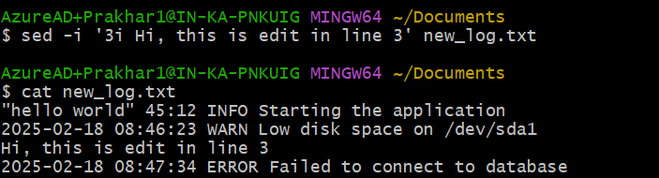
i. Delete the old log file.
j. Filter entries containing the "INFO" string for a particular date for a given log file, you can use the sample log file given below.
1. Using piping:
grep "2025-02-19" new_log.txt | grep "INFO"
Piping Explanation (|): The pipe (|) takes the output of the command on the left and feeds it as input to the command on the right.
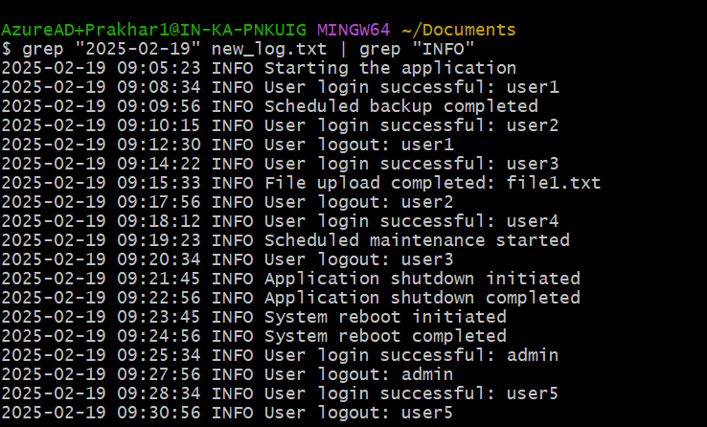

2. Can also use extended regex:
i.e. we can combine the two grep commands into a single one using grep with extended regex (-E) and .* wildcards:
grep -E "2025-02-19.*INFO" new_log.txt

